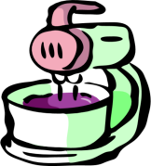
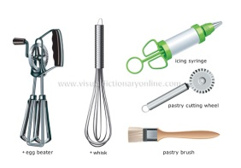
Principles of Baking
Poster Project
/20
- Read the chapter on baking in the “Discovering Food and Nutrition” textbook and create an informative poster about baking (p.348)
- You must have the following:
- A creative title.
- Subheadings explaining the following terms:
- Flour
- Liquids
- Leavening Agents
- Fats and Oils
- Eggs
- Flavorings
- Baking Soda versus Baking Powder

Rubric /20
 | 9-10 | 7-8 | 5-6 | 3-4
Coverage of the Topic | Details on the poster capture the important information about the topic and increase the audience’s understanding. | Details on the poster include important information but the audience may need more information to understand fully. | Details on the poster relate to the topic but are too general or incomplete. The audience needs more information to understand. | Details on the poster have little or nothing to do with main topic.
Organization | Information is very well organized with clear titles and subheadings. | Information is organized with titles and subheadings. | Information is organized, but titles and subheadings are missing or do not help the reader understand. | The information appears to be disorganized.

