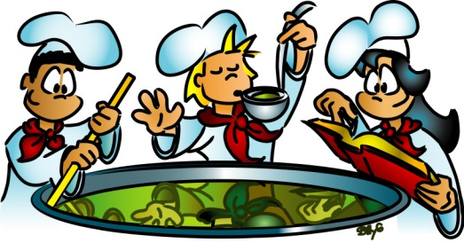
Basic Cooking Terms
- Write down the following terms in your notebook.
- Write a definition for each term and give an example.
- Pare: for peeling and coring foods or mincing and cutting small items.
Ex: Working with small bits of food or small ingredients, such as shallots, garlic or fresh herbs can easily be accomplished with this knife.

- Peel: To remove the rind or skin from a fruit or vegetable using a knife or vegetable peeler.

- Grate/shred: To shred food by rubbing it against a grater.
- Melt: Using heat to convert food (e.g. butter,chocolate) from a solid to a liquid.

- Season: to add salt, pepper etc to food you are cooking
- Dredge: to coat an item of food in flour or breadcrumbs before cooking it.
- Sauté: to cook in a small amount of fat; pan-fry.
- Steam: Steaming can be done on a stovetop, with a pot containing a small amount of liquid that is brought to a simmer.
- Stir-fry: Simply toss and turn bite-sized pieces of food in a little hot oil in a wok over high heat, and in five minutes or less, the work is done.
- Drain: Refers to the process of pouring off the excess liquid or fat from food such as draining the water from boiled pasta or potatoes.

- Blend: The process of combining two or more ingredients together so that they lose their individual characteristics and become smooth and uniform. For example, cake batter is the result of dry and liquid ingredients that are blended together in a uniform mixture

- Beat: To smoothen a mixture by briskly whipping or stirring it with a spoon, fork, wire whisk, rotary beater, or electric mixer. Ex: Eggs
- Grease: to put butter, grease etc on a pan etc to prevent food from sticking to it: Grease the pan before you pour the batter in.

- Knead: A method of mixing pliable dough by stretching, folding and pushing in order to form gluten in the flour
- Marinate: The soaking of food, such as meat, vegetables, or fish, in a flavored liquid for the purpose of flavoring and tenderizing foods before cooking.
- Mash: To crush foods (e.g. boiled potatoes) into a smooth, evenly textured mixture.
- Simmer: Simmering is a food preparation technique in which foods are cooked in hot liquids kept just below the boiling point of water
- Whisk: Whisks are used to blend ingredients together quickly or to incorporate air into ingredients such as egg whites or heavy cream in order to increase the volume of the mixture.
- Brown: To cook over medium or high heat until surface of food browns or darkens
- Broil: to cook under direct heat.

